

SOLVERMINDS

**Solverminds Solutions & Technologies Pvt Ltd**

|  |  |
| --- | --- |
| Document Title | Understanding Document for  **Risk Mapping Portal**  **for**  http://teekay.com/wp-content/uploads/2014/08/logo-full.png |
| Document Ref | TEEKAY-2017/01 |
| Document Version | 1 revision 1 |
| Date Submitted | March 6, 2017 |
| Key Contacts | Anthony Damian, Managing Director  [adamian@solverminds.com](mailto:adamian@solverminds.com) |

Table of Contents

1. Introduction 3

2. Why SOLVERMINDS? 3

3. What is Balanced Score Card? 3

4. Why Balanced Score card? 3

5. Solution Scope & Implementation Approach 4

5.1 Solution Scope 4

5.2 Application Development Scope 4

5.3 Proposed Features for VBS 5

5.4 Development & Implementation Approach 6

5.5 Vessel Balanced Score card & Vessel Performance parameters: 7

5.6 Sample Teekay Vessel Balancedd Scorecard 8

5.7 Suggested Workflow & Architecture 9

5.8 Benefits Of This Architecture 9

5.9 Implementation Resources 9

6. Responsibilities 10

7. Dependencies & Critical Success Factors 10

8. Quotation & Terms of Payment 11

8.1 Total Cost for Risk Mapping Portal – Phase 1 11

8.2 Total Cost for Training Offsite 11

8.3 Travel & out-of-pocket Expenses 11

8.4 Payment Schedule 11

8.5 Annual Support and Maintenance 11

9. Project Schedule & Milestone 12

# Introduction

SOLVERMINDS (***hereinafter referred to as* “SVM**”) is pleased to submit an understanding document for the development of the Risk Mapping Portal for Teekay Tankers Ltd. (***hereinafter referred to as* “TEEKAY**”). This document is to assist with the submission of a project proposal that will include more refinements to the scope, project schedule, project costs etc.

# Why SOLVERMINDS?

* SVM’s predictive findings were instrumental in decisive initiatives taken by Teekay management to achieve 2016 vetting inspections goals. These initiatives have already assisted Teekay with reducing vetting risks
* Extensive Domain Experience in Shipping Logistics. Partnership with leading Shipping companies for BI & Analytics projects - **NYK, K-Line, UASC, ESL and several others**
* We have a large resource pool of Certified MS SQL/Java Engineers
* We have extensive experience with various BI & Analytic tools

# What is Balanced Score Card?

The balanced scorecard is a strategic planning and management system that is used extensively in business and industry to align business activities to the vision and strategy of the organization, improve internal and external communications, and monitor organization performance against strategic goals.

* *An improved strategic planning process for focusing on the most important things;*
* *A change initiative for visualizing and communicating an organization’s long-term strategic intent;*
* *An effective strategic management system for aligning dayto-day work to an organization’s vision and strategy using strategic performance measures and strategic initiatives;*
* *An integrated framework for informing strategic budgeting, and allowing the organization to learn what works and to become more strategy focused.*

# Why Balanced Score card?

The measurement of performance is essential in business practice because it assists organization to evaluate the achievement of business goals, points out challenges and provides direction of possible improvement actions.

# Solution Scope & Implementation Approach

## Solution Scope

**Phase 1: Vessel Balancedd Scorecard – VBS**

* + - To see Balanced Scorecard for each vessel
    - See historical trends of Vessels VBS
    - To provide visibility into historical data which reflects poor performance resulting in high risk on-board environment
    - Assist in identifying the common elements which lead to it (causes for poor performance)
    - Definition of success for Vessel Performance
      * *No L3/L4 incidents*
      * *No Injury (Restricted work case)*
      * *No Complaints*
      * *No PSC Inspections*
      * *Zero Avoidables*

**Phase 2: Vessel Performance – Identification of ‘Rogue’ Ships**

* + - To identify vessels that are result in high risk on-board environment
    - Identify & Collate all parameters for these vessels (create data repository)
    - Identify patterns (officers, weather, vetting, purchasing agent, vessel manager, etc) that correlate to poor performance/high risk
    - Create & Build Predictive Analytics Model
    - Use the current data of vessels and identify POTENTIAL vessels with a propensity for poor performance
    - Take Preventative Actions

**Phase 3: People Mapping**

* + - To find the patterns of officers whose presence on-board generate a high risk environment
    - To use Predictive Analytics to mitigate high risk
    - Create a data repository of Officers & Engineers (4+2)
    - Identify the performance/strength for each individual for each vessel
    - Create a performance profile (score) based on vessel /other performance indicators
    - Create optimization techniques to maximize impact score by assigning the right resources for current & future allocation
    - Mixing varied officers (4+2) , to optimize the Right Officer/Right Ship combination
    - Build What-if scenarios

## Application Development Scope

**This understanding document only focuses on Phase 1 – Vessel Balanced Scorecard (VBS)**.

This VBS Solution offers TEEKAY an ability to identify ship and crew performance to help the management team to make better informed decisions. The data will be collated from Teekay’s Operational & Financial data warehouse

The solution proposed will use various technologies (*Java, MSBI, AmCharts, SQL Server etc.*) and the final Balancedd scorecard will be delivered through a customized risk mapping portal hosted on Teekay’s internal servers with appropriate access rights management features

The scope of development includes:

* Creating detailed specifications for each KPI (data source, data fields required, charts)
* Application development for **Phase 1 – Vessel Balanced Scorecard** including Database design (data cube), Front-end and Middle tier development
* Ensuring data quality and uniform data mapping from all consolidated data sources
* Assistance with hosting on Teekay’s pre-production & production servers
* System Testing prior to Go-live
* Training & User Documents
* Online SVM’s JTRAC access for logging system incidents report
* Technical support
  1. Online chat client (Skype) support
  2. Email support

## Proposed Features for VBS

1. Java Web based solution incorporating industry standard security & encryption protocols
2. Master Administrator Controls
   1. To control and set access rights
   2. Log all activity
   3. Set alerts & reminders (threshold, type of media for alerts)
   4. Edit, Add & Remove KPI’s, weightage, threshold, etc.
   5. Set Frequency of Data Update
3. Cascading style with drill-down features (*relational tree structure with expanded view)* displaying how each of the KPI’s and the final Balancedd Scorecard have been calculated
4. Ability to retrieve and consolidate data & creating linkages of data from various sources (*with database integrity checker*)
5. Various charts to visualize key KPI’s
6. Customizable Filters (such as setting reporting & historical dates, etc.)
7. Ability to conduct what-if analysis
8. Ability to create and publish reports in PDF format for each SPI, KPI or PI and final Balanced scorecard and post it to the current VBS Sharepoint Portal
9. Ability to add comments such as insights against each dashboard
10. On-screen help

## Development & Implementation Approach

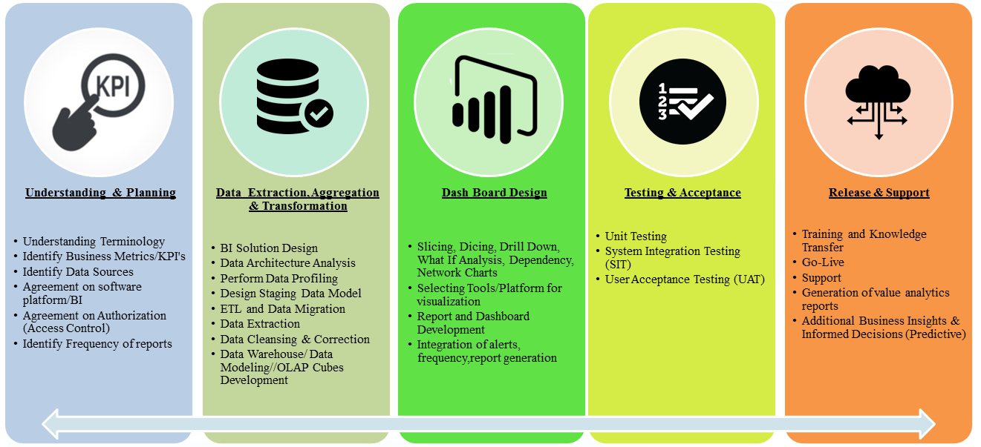

## Vessel Balanced Score card & Vessel Performance parameters:

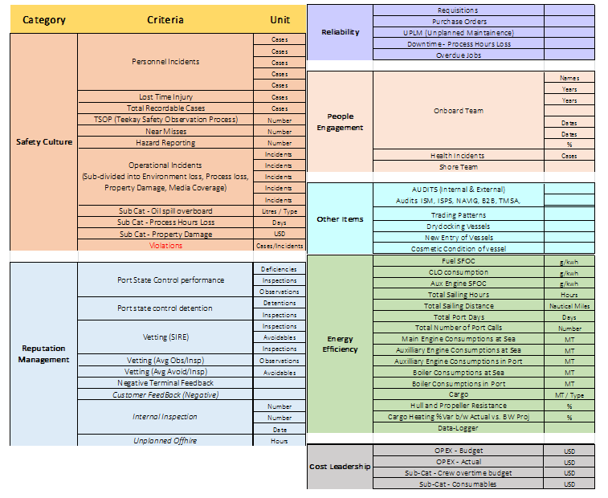

## Sample Teekay Vessel Balancedd Scorecard



## Suggested Workflow & Architecture

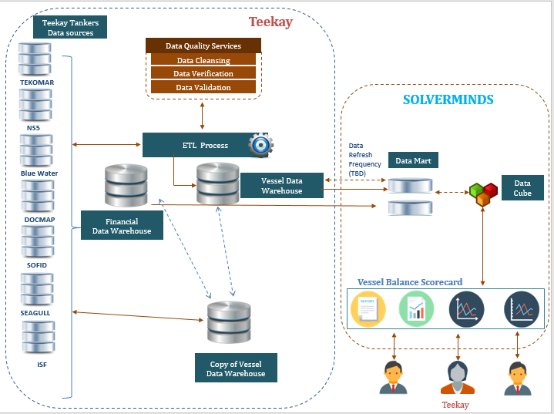

## Benefits Of This Architecture

* Data required from various data sources will be collected from the DW
* Consistency Mapping of master data and maintenance is easier
* Data cube can be changed without any impact on production server or VDW
* Frequency of update can be controlled easily
* No impact during SQL server migration/upgrade

## Implementation Resources

|  |  |  |
| --- | --- | --- |
| **S. No** | **Role** | **Skill Set** |
| 1 | Team Leader | Business Intelligence and Analysis  Predictive Analytics  Software Quality |
| 2 | BI Analysts | Business Intelligence and Analytics  Software Quality  Qlikview, PowerBI, SharePoint  SQL Server Knowledge |
| 3 | DB Modeler/Analyst & Administrator | SQL Server 2008/2014 & DWH Specialist  Experience in ETL & Data Modeling  Data Cleansing & Preparation  Configuration of Database |
| 4 | Java Developers | J2EE, Portal Development  AmCharts  ERP Implementation  Dashboard Design |
| 5 | Testing & Release Coordinator | Quality Assurance  Deployment  Assistance with hosting of application & database setup |

# Responsibilities

Following are the responsibilities of each contracting parties:

|  |  |
| --- | --- |
| **Teekay** | **SVM** |
| * Act as a data provider * To allocate one or more resources with sufficient business process knowledge to assist SVM to design, configure and deployment the VBS system * Verify and validate the BI Analysis report and data findings | * Assignment of Team Leader. Team Leader will be the focal point for all project related communication and all requirement / deliveries will be routed through Team Leader only.  1. *Project communication* 2. *Project Planning* 3. *Project Monitoring & Control* 4. *Delivery & Post Delivery tracking* 5. *Creating technical requirements document* |

# Dependencies & Critical Success Factors

|  |  |
| --- | --- |
| **Teekay** | **SVM** |
| * Description and documentation of current Vessel Data Warehouse (VDW) architecture * Availability of Data Dictionary * No. of years reporting * Availability, Quality and Data Integrity for creating data marts/data cubes from VDW & FDW * Confirmation of no. of users Tech, HSEQ, Operations for Ship Management * Confirmation of access rights heirarchy | * To ensure proper data mapping from each database for creation of master data cube * Manual to electronic transfer of hazard log |

# Quotation & Terms of Payment

## Total Cost for Risk Mapping Portal – Phase 1

|  |  |  |
| --- | --- | --- |
| **S. No** | **Item** | **Amount in USD** |
| 1 | Development of Risk Mapping Portal – Phase 1 | TBD (Fixed Price/ Time and Material) |

## Total Cost for Training Offsite

|  |  |  |
| --- | --- | --- |
| **S. No** | **Item** | **Amount in USD** |
| 1 | Training | TBD |

Note:

1. Errors & Omissions Excepted
2. All prices quoted do NOT include any applicable local taxes. Any applicable tax will be included at time of invoice.
3. Payment is to be made by telegraphic transfer to the designated banking account of SOLVERMINDS as indicated on the invoice.
4. Payment shall be made by TEEKAY within Thirty (30) days from the date of invoice.

## Travel & out-of-pocket Expenses

Travel expenses for flights, local transport and accommodation incurred for the project implementation, deployment & training and all other project related out-of-pocket expenses of SOLVERMINDS employees will be charged as occurred.

All services rendered and incidental cost (travel and out-of-pocket expense) incurred by SOLVERMINDS employees will be invoiced immediately and are due for payment by TEEKAY within 7 days of invoice receipt.

## Payment Schedule

|  |  |
| --- | --- |
| **Description of payment** | **Amount USD** |
| 50% upon PO issue  50% on Phase 1 - VBS Deployment | TBD |
| **Total Cost** | **TBD** |

## Annual Support and Maintenance

Annual support and maintenance shall commence from date of deployment of VBS

|  |  |  |
| --- | --- | --- |
| **Description of Annual Support Services** | | **Annual Fee USD** |
| Annual Support and Maintenance (AMC) | TBD | |

# Project Schedule & Milestone

The schedule provided here is only an estimate. The actual schedule will depend on the final date of project start and availability of all required data.

